**State transition Diagram**

**1. Atm Card State Transition Diagram:**

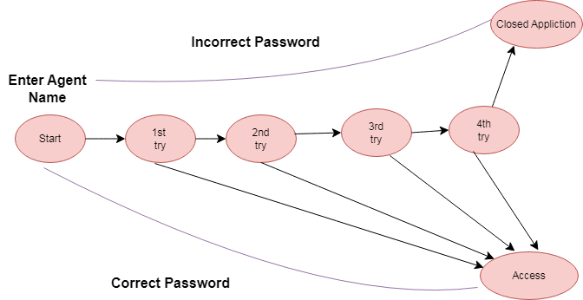

**2. Process State Diagram:**

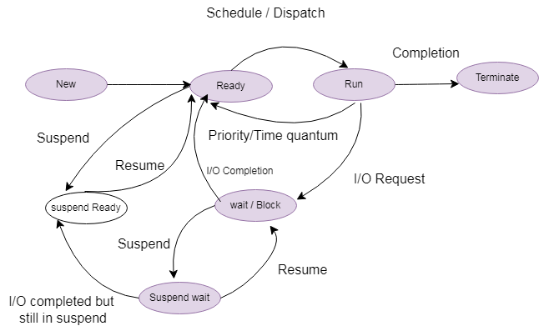

**3. Send Email And Receive Email Diagram:**

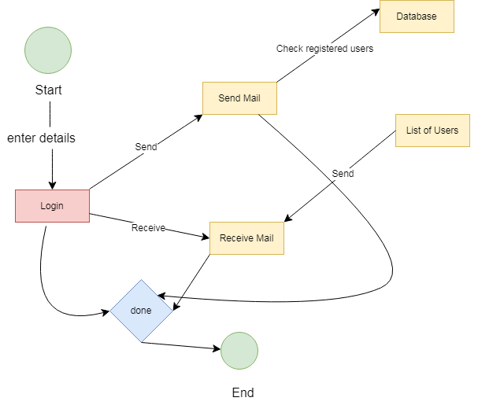

**4. Creating and building profile Diagram:**

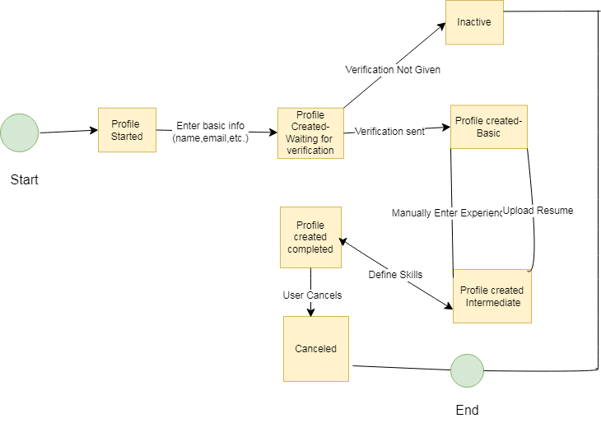

**5. Library Management system:**

